**物理講演会 Report02**

「Exotic phenomena emerging from magnetic interactions」

Harald O. Jeschke 教授

In this lecture, Prof. Harald introduced the history of superconductivity and the recent research results involving magnetic interactions.

He first introduced the history of superconductivity and the BCS theory, At sufficiently low temperatures, electrons near the Fermi surface become unstable against the formation of Cooper pairs. Cooper showed such binding will occur in the presence of an attractive potential, no matter how weak. In conventional superconductors, an attraction is generally attributed to an electron-lattice interaction. The BCS theory, however, requires only that the potential be attractive, regardless of its origin. In the BCS framework, superconductivity is a macroscopic effect which results from the condensation of Cooper pairs. These have some bosonic properties, and bosons, at sufficiently low temperature, can form a large Bose–Einstein condensate. Superconductivity was simultaneously explained by Nikolay Bogolyubov, by means of the Bogoliubov transformations.and then he introduced the several exists superconducting material such as cuprate superconductors, which was the first high temperature superconductors.

There are several accepted common rules, such as “stay away from oxygen” 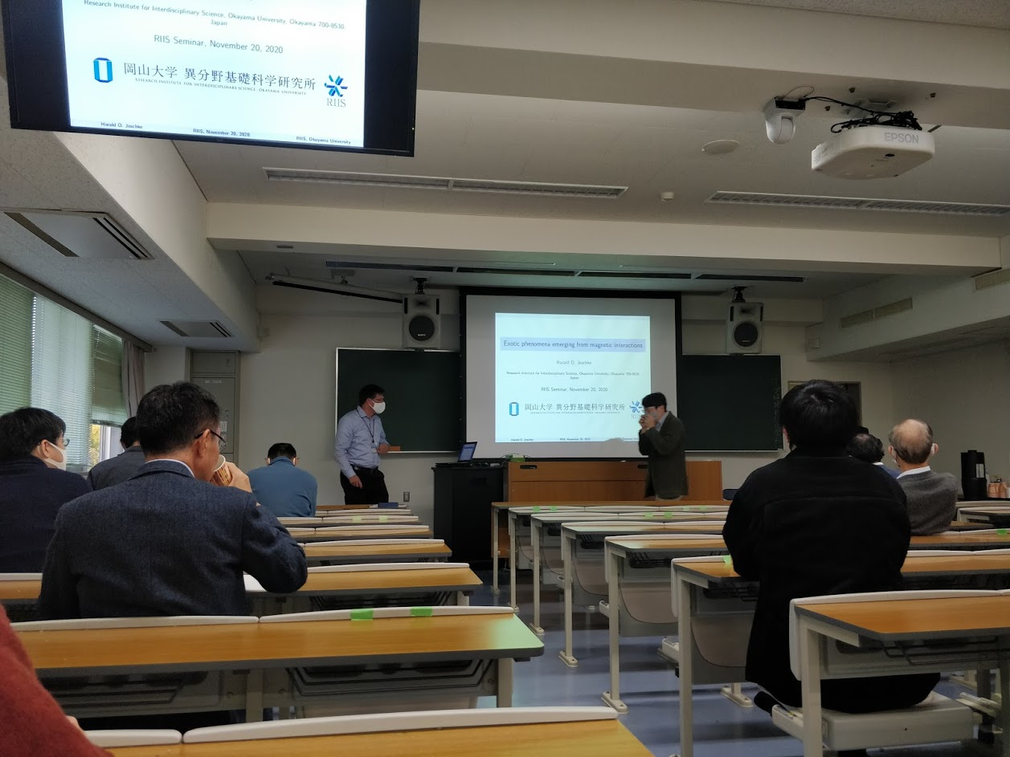

and “stay away from magnetism”, but cuprate have both properties.

And he also mentioned the nematic symmetry broken in FeSe. By excite the so called spin ice, they observed the magnetic monopoles.

